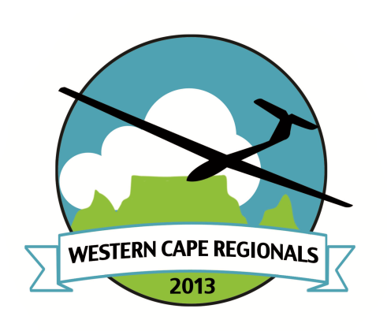
Cape Gliding Club
Western Cape Regionals 2017
Indemnity Form
Please print this form, fill it in using capital letters, sign it and hand it over to the Organisers when you arrive at the competition.
1. I, the undersigned _____________________________irrevocably indemnify the organizers and or personnel of the Western Cape Regional Gliding Championships, the Soaring Society of South Africa, the Aero Club of South Africa, Cape Gliding Club and its agents from any claim I, my heirs or estate may have arising out of any injury to myself or caused by myself or my death as a result of competing in this Competition.
2. I declare that I comply with all the legal and currency requirements for piloting a glider in my country of origin and in South Africa.
3. I declare that my glider (registration _____________ and call sign _____________) conforms to all airworthiness requirements.
4. The glider is insured by ________________ for Third Party cover to the value of R______________
4. I accept the handicap system and values as published by the Soaring Society of South Africa and understand that these handicaps will be applied for the duration of the competition (available at www.sssa.org.za).

Signed:______________________________at _________________________

This:____________________________ day of __________________2017

Witness 1: Name in capital letters ________________________________
Signature ______________________________

Witness 2: Name in capital letters ________________________________
Signature ______________________________

